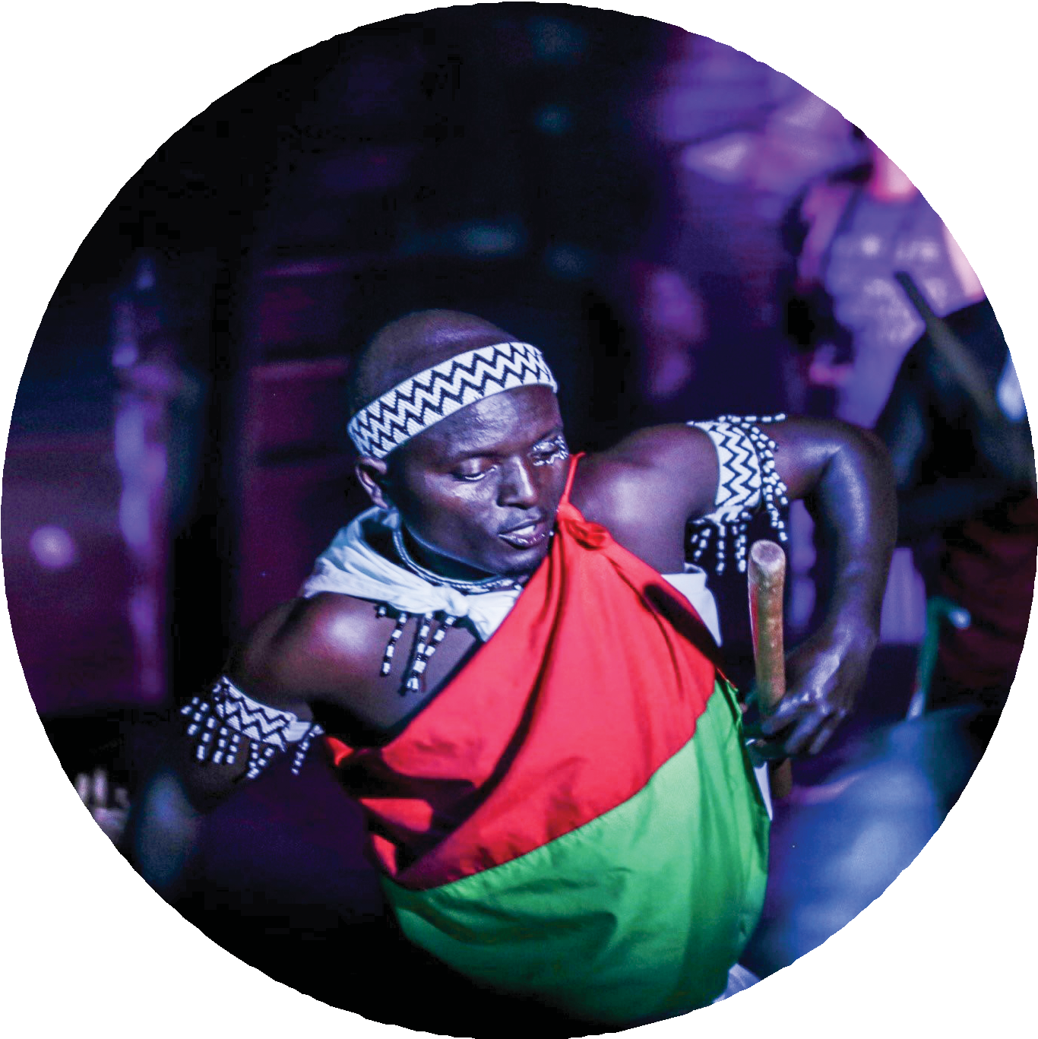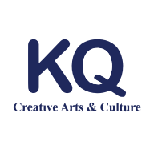A P R I L 2 0 2 0

COVID-19 AND ITS IMPACT ON UGANDA’S CREATIVE INDUSTRY
Wabwire Joseph Ian

COVID-19 AND ITS IMPACT ON UGANDA’S CREATIVE INDUSTRY APRIL 2020 2

Table of Contents

Covid-19 and its Impact on Uganda’s Creative Industry 1

Introduction 3
Impact on Visual & Performing Arts in Uganda 3
Government Intervention is a necessity 6
Sector resilience & Ingenuity amidst a crisis. 7
Emergency Interventions in the Arts sector. 10
Learning, creating and reﬂection during and after a crisis 11
About the Author 12
Acknowledgements 12
COVID-19 AND ITS IMPACT ON UGANDA’S CREATIVE INDUSTRY APRIL 2020 3

Introduction

In declaring a national wide lockdown on the evening of 30th March 2020, President Yoweri Kaguta Museveni made it clear how seriously the government views the threat of the coronavirus pandemic. An infectious virus that has disrupted various sectors within Uganda's economy - the Arts & Cultural sector being the hardest hit. "Social-distancing" a measure being adopted globally to contain the spread of coronavirus cannot work hand in hand with an industry that solely relies on communal gatherings and social close interac- tions as the DNA of its business model.

With the new measures in place, hundreds of artists and arts organizations in Uganda are facing an unprecedented loss of livelihood and incomes due to the worsening COVID-19 pandemic and the measures put in place to contain it.

Impact on Visual & Performing Arts in Uganda

As a measure to contain the spread of COVID-19, nearly all the country's major events including concerts, theatre shows, museum visits, live music shows, poetry nights, comedy shows, and exhibitions have been cancelled with tight restrictions to enforce and promote social distancing. Prominent venues and art centers like the Uganda National Museum, The Uganda National Theatre, Ndere Cultural Centre, Afriart Gallery, Nommo Gallery among others have since closed their doors in the interest of public health.

Leisure spaces like cinemas, coﬀee shops, bars, restaurants, clubhouses, casinos, sport centers, hotels, that are mostly frequented by freelance artists who do gigs like live music shows, poetry nights, Deejaying, concerts, and ﬁlm screenings have also seen closure given the drastic government measures.

To track the impact caused by COVID-19 on the work of freelance creatives in Uganda, KQ Hub Africa did an online survey from March 17 to April 1. Based on the Covid-19 Arts Impact Survey carried out, the arts industry and artists collectively have lost over 500 million Uganda shillings nationwide from the cancellation of over 300 events impacting 700 artists and their fans.

The Creative Industry model relies almost exclusively on its ability to bring people together in mass that purchase tickets to attend concerts, poetry nights, exhibitions, theatre show- casing, museum visits, and comedy shows, among others. Generating income from ticket sales and events allows artists and artists’ organizations to sustain themselves and the livelihood of their staﬀ and families, in addition to the general public supported by their tax remittances.

IThe much anticipated Eddy Kenzo Festival presented by popular singer and award-win- ning Edriisa Musuuza, known as Eddy Kenzo, was scheduled to take place on 28th March, 2020. It has since been postponed indeﬁnitely due to the crisis. This unexpected turn of events frustrated him as evidenced by one of his tweets. "Mugamba lwaki sinavayo kuyamba naye ntandikirewa nga nange netaga buyambi. I invested all my money in the festival mukama nagera bwatyo." Eddy Kenzo tweeted on 30th March 2020. Literally saying that people are blaming him why he has not oﬀered any support in the ﬁght against Covid-19 yet he invested all his money in the festival and God's plans didn't favor his schedule to earn from his investment.

Scheduled weekly comedy shows that bring mammoth crowds of revelers who seek to be entertained hosted by groups like Fun Factory, Comedy Store and Just Comedy have also been postponed. The comedy shows are organized by reputable comedians like Alex Muhangi, Richard Tuwangye, Hannington Bugingo, and Patrick Salvador. Several other emerging comedians get gigs on these comedy shows that have been a source of income that is now no more.

Further adjustments can also be seen with the Uganda National Cultural Centre (Uganda National Theatre). On the eve of commemorating the World Theatre day which was sched- uled on the 27th March, 2020, Uganda National Theatre started an online campaign calling upon persons that are part of the value chain of the theatre to read and share a monologue as a way of celebrating this year’s World Theatre Day following the cancellation of the celebrations that would bring people together to share their theatre experiences on World Theatre day. The celebration was dubbed “Beyond Conﬁnement”.

The pandemic continues to further disrupt the performing arts sector like the regular dance performances, live music shows, poetry nights which are not happening because art centres, dance studios, art hangouts, bars and coﬀee shops that are homes for these events have since closed down.

A poetry night “She Wrote it, She Speak It” organized by Open Mic featuring poets like Gloria Kiconco, Arinda Daphine and Jayne Rashida that was due to take place on 28th March 2020 at Bushpig Backpackers Kampala Acacia Avenue was cancelled among many other poetry showcasing.

As for the visual Arts, most galleries rely on funding and the sale of art paintings in their exhibition collections to raise income and sustain their existence. However, regular gallery exhibitions hosted by the Uganda National Museum, Afriart Gallery, Nommo Gallery and the Uganda National Cultural Centre have since been postponed until COVID-19 crisis recedes. Artists meant to travel and attend international exhibitions, Art residencies, exchanges, fairs, biennales, and auctions have since found themselves with no options but to stay home due to the travel restrictions put in place. This has further aﬀected their income generating options seeing as many had hoped that attending these would guarantee them some incomes.

According to the Covid-19 Arts Impact Survey carried out by KQ Hub Africa, 80% of the artist and Artist organization respondents rely on these community events for a large proportion of their income to supplement their freelance earnings and sustain their livelihoods. Now that it isn't the case, they fear this will aﬀect them greatly. Artists are wondering what they all are going to do in this crisis. Most artists, managers, booking agents, DJs, sound engineers and bar staﬀ have little or no savings, relying on regular gigs to cover their living costs.

Asked how he has been aﬀected, Eugene Kavuma, Founder Kampala Design Week expressed his frustration about this whole crisis and in his response said that "The mode of transmission of the virus has made it impossible for us to hold in person meets which has left us without any means of earning income"

COVID-19 AND ITS IMPACT ON UGANDA’S CREATIVE INDUSTRY APRIL 2020 6

Government Intervention is a necessity.
How governments respond now to oﬀer social protection to sections of people in the creative industry during this crisis and its impacts could have far reaching consequences on the sector, the livelihoods of artists, event promoters, arts organizations, cultural centers and the future prospects of the creative industry once the virus recedes.

Sowedi Uthman, Hub Manager, Jabulani Arts Hub, Fort Portal says that “COVID-19 has caught everyone unaware across the board, and for the creative sector equally unaware too, and as a sector it has faced it rough since most measures to ﬁght the virus curtail the engine of arts growth which are social gatherings and mobility of individuals.”

According to the Covid- 19 Artists Impact Survey, 73% of artists and arts organizations believe that government has not done much to support the Creative Industry on a whole and that in times like these, it's no surprise that they would be left on the margins of having to ﬁgure out how as a collective they can gather themselves to confront the grinding negative impacts of this crisis.

The creative arts sector employs approximately 30 million people worldwide and these will be among the most hit by the pandemic according to analysts and reports carried out.
Individual artists are already struggling to maintain their livelihood. The creative arts industry notably employs a larger section of the youth who are now clueless on how they will generate any income to sustain their livelihood should the situation exacerbate.

“I don’t see any government support to the creative industry, but instead I have only seen the creative industry support government through creation of content both in audio, visual materials that break down information and measures to ﬁght COVID-19. Already so many artists have designed graphical content, recorded music that has ampliﬁed local people to take washing hands seriously and keep social distancing. It’s a shame somehow that just as a norm has been for government failing to support the sector even at this critical moment and vulnerability when festivals, concerts, exhibitions among others have been cancelled the government is still adamant on supporting the sector.” Says Sowedi Uthman, Hub Manager, Jabulani Arts Hub, Fortportal

According to the United Nations agency UNESCO, the cultural and creative industry sectors generate annual revenues of US$ 2,250 billion and global exports of more than US$250 billion. In Uganda, culture and creative arts are estimated to generate approximately Shs
3.18 billion to the economy in total business income based on analytical estimates. This industry currently provides nearly 30 million jobs worldwide and employs more people aged 15 – 30 than any other sector.
This is reﬂected in a 2018 report by UNESCO,” Reshaping Cultural Policies”

The fears are not only on how to survive but also include rising mental health concerns, ﬁnancial security and community connectedness. These concerns cannot be underestimated when persons in the sector have no means of sustaining livelihoods.

Sector resilience & Ingenuity amidst a crisis.
Amid these tough times for the creative and arts industry, not all hope is lost. This crisis makes a clarion call for embracing innovative avenues aﬀorded by the diﬀerent online digital platforms to get educative messages to control the spread of the virus across the globe.

Despite the above mentioned negative impacts caused by COVID-19 on artists livelihoods and incomes, Artists through this crisis are still creating, innovating and oﬀering a ray of hope to
majority of people who are mentally distressed and need music, humor, ﬁlm, visual arts to
keep sane while still practicing social distancing by staying home.

Artists are using their creative skills to sensitize masses about how to navigate the times by creating educational audio-visual content, illustrations, and visual skits that they are sharing through various social media platforms and using live stream options like Zoom, Skype, Twitter, Instagram, and Facebook to host intimate live music shows, concerts, and webinar sessions with their fans. This content ranges from graphical content, recorded music and poetry, online museum exhibitions and gallery views, online Live Stream comedy watch parties, online Deejay shows and group parties, ﬁlm screenings etc.

Globally acclaimed Singers such as John Legend and Chris Martin have been streaming concerts via their social media accounts as part of the “Sessions: Together, At Home” series - an initiative launched by the Global Citizen Festival and World Health Organization.

In Uganda, artists are also complementing the government eﬀorts in preventing the spread of the virus. Comedian groups like Fun Factory Uganda are broadcasting their content on Facebook and YouTube urging people to stay home and enjoy comedy in the comfort of their sitting rooms in a bid to enforce social distancing. The group is running a campaign dubbed “Stay Home- Stay Safe; Load Data and Watch Live Online”.

The campaign is being boosted online with hashtags like #HomeTheatre #LockDownTimes #Comedicine #StayHome and on 20th March 2020 they entertained over 15,000 people on their streaming as they encouraged people to stay smiling in the lockdown. Fun Factory Uganda further broadcasts and posts Ministry of Health Uganda's messages on their social media platforms in a bid to help their large followings to get ﬁrst-hand information on how to control the virus and latest information on Covid-19. The viewers on Facebook appreciated what Fun Factory was doing to keep people entertained in such unusual times. A one Ssendawula Karim Abdul commented saying that "We appreciate you keeping a smile on people's faces in these times even though they can't make it to the theatre.
That's a service. Be blessed" Another Facebook user commented saying Munene Chantal expressed her appreciation in her comment " I appreciate you mostly in this crisis "Other comedians are also championing the sensitization by creating skits for example a skit from Zubairi Family encouraging social distancing has been trending on WhatsApp and Facebook.

Recording artists have also recorded songs that are sensitizing the public in Uganda and the whole international community on the precautionary measures of containing the spread of the virus. On 24th March 2020, Robert Kyagulangi a legislator and leader of the People Power Movement alias Bobi Wine and his colleague Nublian Li released a song titled “Corona Virus Alert” that was emphasizing the need for social distancing and wash- ing hands to prevent the spread of the virus. The song further highlighted symptoms of the virus and encouraged people to seek medical attention in case they are having any of the symptoms. The song has greatly sensitized people and one Tweep @MuhindaPraiz tweeted resonating with the song that "The bad news is that everyone is a potential victim but the good news is that everyone is a potential solution… #StayHome #StaySafe Great Message" The song has ruled the airwaves in Uganda and has also featured on prominent international platforms like Aljazeera, CNN, and The Guardian. This has been followed by other compositions from other artists like Bebe Cool, Vinka, Fic Fameica , A-pass and several others encouraging people to social distance and wash hands.

Organizations world over are slowly recognizing the importance of using Arts and Culture as a tool for promoting social solidarity and awareness. For this very reason, Brenhurst Foundation has made an eﬀort to bring artists and leaders across Africa together to compose a song of hope in this time of crisis. The song is titled “Alone Together” featuring Uganda’s Bobi Wine, South Africa’s Greg Mills, Robin Auld, Unity Mzi and Nigeria’s Amuta Stone. Some African leaders that are part of the song include H.E. George Weah, H.E Muse Bihi Abdi, and other former presidents like Ellen Johnson Sirlief, Joyce Banda, F W de Klerk and Olusegun Obasanjo.

Illustrators, animators and Cartoonists have also used their art to create awareness around the pandemic but also criticize how government health policies and systems have failed to ramp up eﬀorts at the most desired time. Renowned lecturer, social critic, occa- sional Cartoonist and contributor to The Observer Newspaper columnist, Dr. Jimmy Spire Ssentongo who on his return from United Kingdom is under institutional mandatory quarantine has kept his spirits high while in isolation by using his cartoon art to contribute to the much desired sensitization despite the traumatizing experience he is undergoing as a result of the quarantine conditions in play. Spire has encouraged people to share the cartoons which have messages in local languages and has given people permission to print and stick the cartoons if they ﬁnd it ﬁt.

Amidst all this, visual artists are as creative as ever as they face extreme restrictions due to the pandemic. Gallery curators have quickly come up with innovative ways to keep interaction with their audiences.

Following the closing of art spaces and galleries. Afriart Gallery Kampala which is currently showing an exhibition and cannot get people to go to the physical space has set up a virtual version of the exhibition; the “Online Virtual Tour” featuring an exhibition curated by Sarah Bushra titled "COLLAGE BROADLY DEFINED" showcasing the works of 5 formida- ble artists from Kampala, Kinshasa, and Nairobi.
Participating visual artists include Cannon Griﬃn, Gael Maski, Letaru Dragu, Eria Nsubuga 'Sane', Maliza Kiasua and Ocom Adonias and over 40 works of art that can be viewed and purchased online without any risk of infection.

KQ Hub Africa a virtual hub space connecting the dots between creative people, brands and culture who over time have gained a lot of their ﬁrsthand experience through using live streaming platforms for their events have encouraged artists to use live streaming as a studio practice and experimental tool for artists to see how to improve their works and also to spark intercultural dialogue on coping during the times of epidemic and crises.
Recently, they hosted Gloria Wavamunno, the Founder Kampala Fashion Week to a live Instagram session on how she was coping as a Fashion Designer and Entrepreneur during the times of pandemics. In her talk, Gloria reiterated the need for sector support from various stakeholders during this crisis and also for artists to use this time to slow down and reﬂect upon how they create art, engage with audiences and build sustainable authentic brands "I hope we take more time to reﬂect upon issues around sustainability, authentic brand development, and more strong pillar support for an industry that everyone turns to when thinking of healing." She said.

The Social media livestream model across various platforms including Facebook, Instagram, Twitter, YouTube is being adopted by artists and arts organizations in Uganda including East African Records that recently hosted a live music Facebook show featuring the artist - Moroot and FEZAH, an online music streaming and monitoring platform featuring their founder talking about the future of Music business during this crisis.

Emergency Interventions in the Arts sector.

With some platforms recognizing that the revenue stream of artists has entirely dried up, platforms like Bandcamp have waived their revenue shares on sales on 20th day of March 2020 and encouraged the Bandcamp community to put much needed money directly into the artists’ pockets. On a positive note fans bought $4.3 million of music and match to support artists impacted by COVID19. The platform further encouraged artists that are not on the platform to register and learn how they can raise income on the platform. Ugandan artists including DJ Kampire Bahana part of the Nyege Nyege Tapes record label has since urged her followers on Facebook and Instagram to stream live her recorded sets whilst also contributing to her income through Bandcamp.

While artists in the country are having to think about alternatives for their performances and income-generation during the peak of the virus, their options are limited because of structural issues such as access to data. Majority of the Ugandan artist population and their audience owns a smartphone, but data costs are exorbitant. More gross is the tax (OTT) levied on accessing social media platforms. Uganda ranks high in the world among over 230 countries in terms of the price of data. Streaming video content is data-intensive and so, while streaming theoretically broadens access to a wider population, this is not necessarily the case in Uganda.

In other creative economies, Emergency Arts Funds are being set up by arts organizations, companies and governments to support artists who have been aﬀected by the pandemic. The European Union a key donor institution for projects in Uganda has created an emergency basic income fund for the players in the creative sector and has further issued a directive that the funds must reach the creative sector immediately. This is a model that needs to be replicated by relevant cultural ministries and organizations or anyone that cares about the importance of Arts and culture in Uganda.

Learning, creating and reﬂection during and
after a crisis.

As the artists in Uganda remain in a state of uncertainty, they are considering all options that allow them to be more creative whilst also keeping their mental health in balance. They are using their alone time to create new art, rethink their models and also contribute with their art to stand in solidarity with all people feeling anxious at this moment. If we care about them as much as they do, we need to support them to continue creating and delivering to us the immersive, interactive and engaging content we get lost into in moments like this.

Amidst all this uncertainty, artists are encouraged moving forward to rethink their business models with an emphasis on sustainability, to start saving for eventualities, to innovate ways of remaining relevant during times of crises and to embrace various digital platforms with business models that can support them during times of crisis. The necessity to embrace digital platforms may not only be necessary in these unusual times but it's likely to become the new normal in the Post COVID- 19 era.

According to the Covid-19 Arts Impact Survey carried out by KQ Hub Africa, 73% of the artists expressed that through this crisis, the world is now inter-connected like never before and challenges like these are bound to always disrupt business as usual in the future. They contend that the silver lining with this crisis is that it will give birth to new business models for artists on digital platforms.

Sowedi Uthman believes this is the time that artists need to be innovative, work with their partners and donors to collectively save the industry so that the pandemic does not see the industry cripple down but come back stronger than ever before. He believes this is possible and achievable and that we have to hold up each other in tough times of this nature, each stakeholder has a role to play.

About the Author

Wabwire Joseph Ian is the Founder & amp; Cultural Producer at KQ Hub Africa, an East African based youth collective, creative agency + virtual hub of Creatives that are putting their best feet upfront to revolutionize the Arts and Culture ecosystem working across visual, digital and performing arts through the production of monthly networking, knowledge sharing experiential and imaginative events like the Creative Talks Africa sessions, artists exhibitions, workshops, concerts, ﬁlm labs + screenings, fashion and design incubators among others. You can reach him at: wabwire@kqhubafrica.com.

Acknowledgements

The author would like to thank:

Wandera Andrew, Eugene Kavuma, Montia Flavia, Phil Wilmot, Wartson Atukwatse and Sowedi Uthman for their detailed reviews and input.

Cover photo Credit: Muhammad Ali Kanchu (KQ Hub Africa/ Ubuntu Rave Project).

Disclaimer

The views expressed in this paper do not necessarily reﬂect the views of KAS but those
of the author

